**University of Technology (Yatanarpon Cyber City)**

**Faculty of Information and Communication Technology**

**Department of Information Science**

**Donor Box (Android)**

Authors - Mg Thwin Htoo Aung (3IST-2), Mg Arkar (3IST-23),

Mg Pau Deih Tung (3IST-12), Mg Aye Min Thant (3IST-53),

Mg Yan Kyar Shan (3IST-51)

Supervisors - Ma Shwe Yamone Oo, Mg Aung Kyaw Mon, Mg Htet Zaw Moe

1. **Introduction**

Donor Box is an application for people who want to donate for whom and where the donation is needed.

**Key Word:** application, donate, donation

**II. Aim & Objectives**

* To find and know which places need help and who need supports from others easily.
* To find activities and events to participate as a volunteer easily.
* To find and donate easily.

**III. System design & Operation**

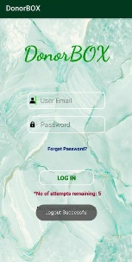 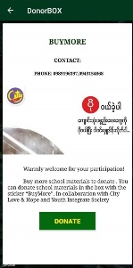

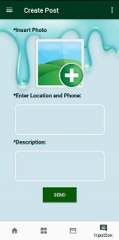

Fig: login page, donation page, post uploading page

**IV. Results, Discussions and Applications**

This project can be used to ask for help and to donate people who need help from others.

**V. Conclusion**

From this project, users can donate people who need support from others and contact us to report that which places need help. Users can participate in our coming events and activities voluntarily.

**VI. Applied Theory/Software/Simulator**

* Android, Java
* Firebase Database